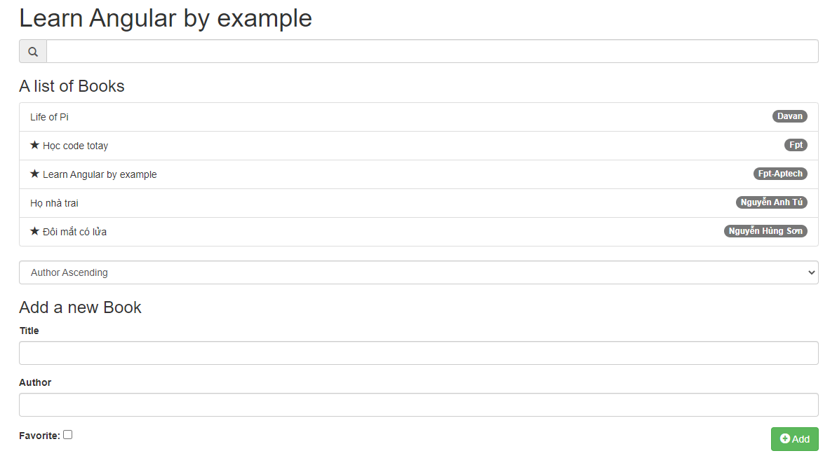

Cấu trúc project

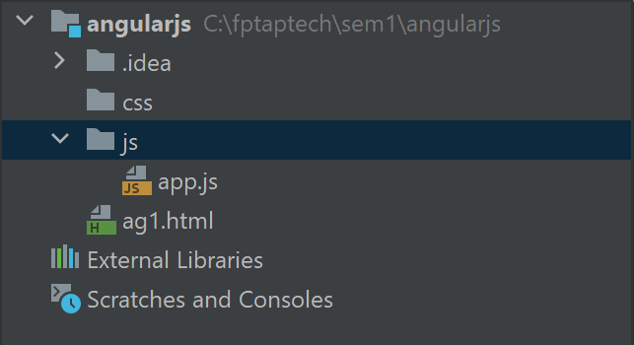

File **ag1.html**

**CDN:  
<link rel="stylesheet" href="https://maxcdn.bootstrapcdn.com/bootstrap/3.3.1/css/bootstrap.min.css">**

**<script src="https://ajax.googleapis.com/ajax/libs/angularjs/1.6.9/angular.min.js"></script>**

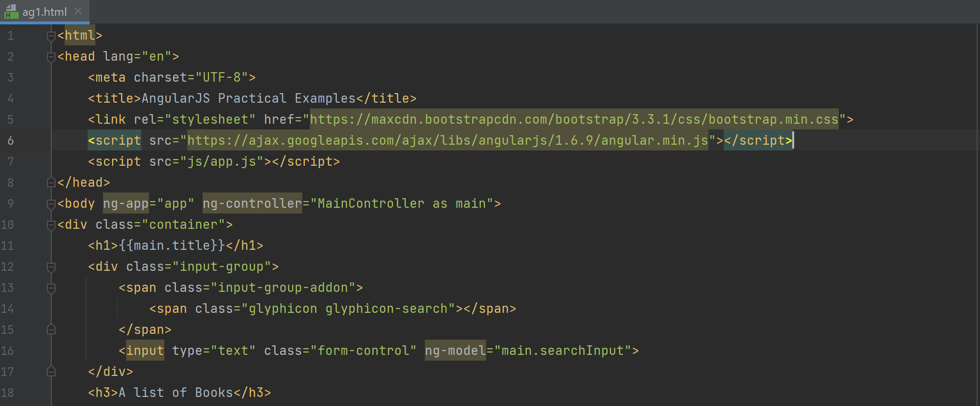

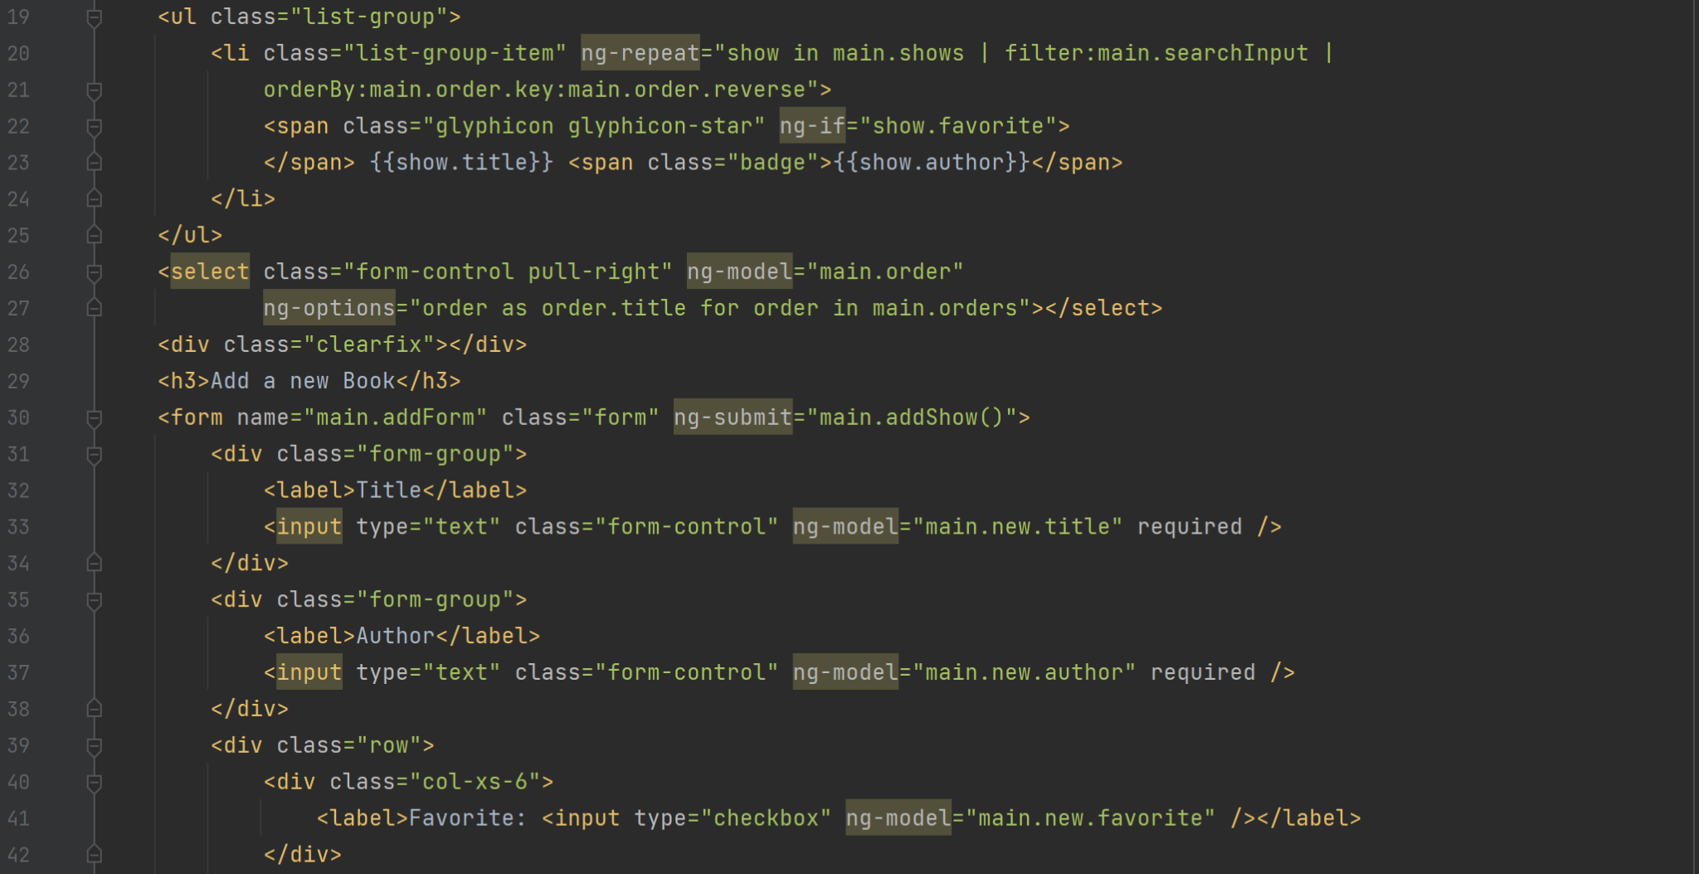

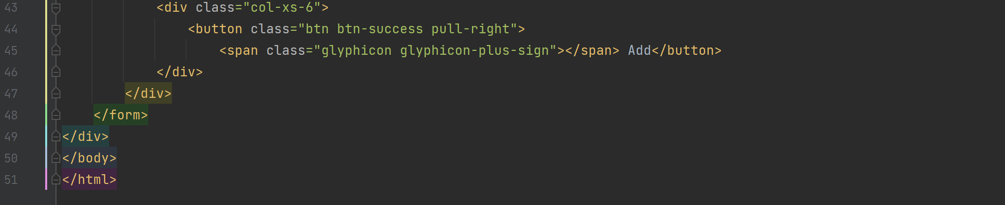

**File app.js**

